**Data Processing:**

The Data Processing step encompasses the extraction, cleaning, and formatting of data from the database into the appropriate format.

**Analytics Layer:**

This layer serves the purpose of ensuring that the data is appropriately structured for integration into the prompt. Its role is twofold: it aids in mitigating hallucination by presenting data in a key-value format (dictionary), and it contributes to the reduction of the prompt size (token size) by dynamically adapting the data to specific use cases.

**For Example:**

**Analysis Goal**: To calculate the year-on-year volume change for a given time series key within a selected level, which may include country, channel, sector, or price tier.

Processed Data

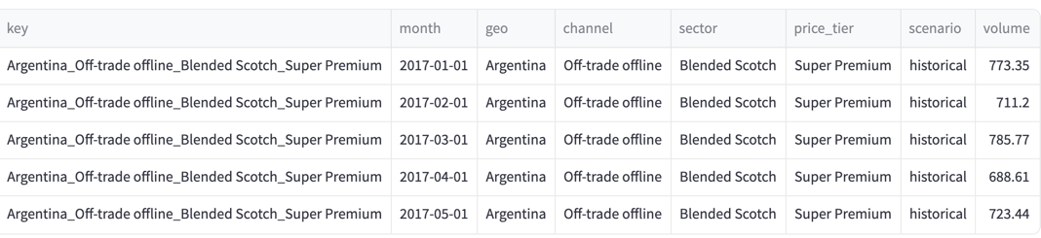

Analytics Layer



1. Select_level()
2. YOY_change()

*#Python Function*

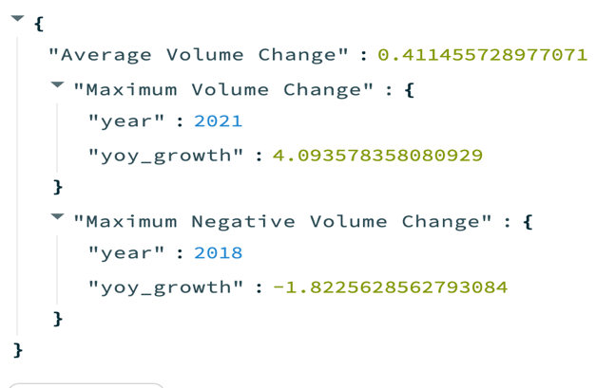

*For a particular at selected level*

**Prompt Engineering:**

**Instruction:**

Guidelines for Model Output Generation

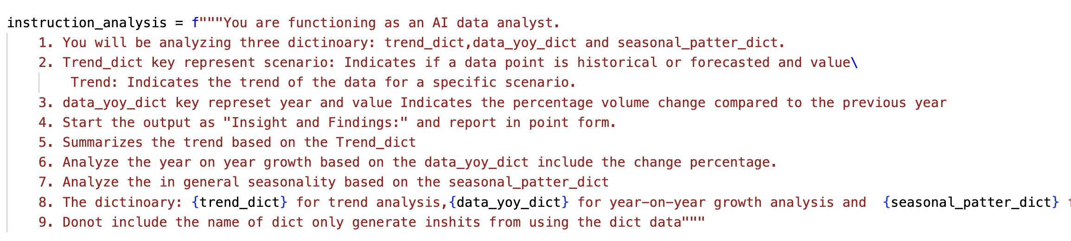

**Context:**

Defining the role of the language model (LLM) to tailor output based on a specific role.

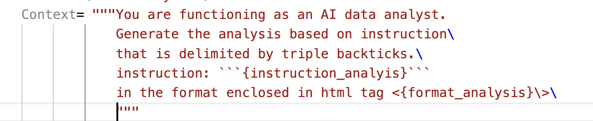

**Input Processing/Format:**

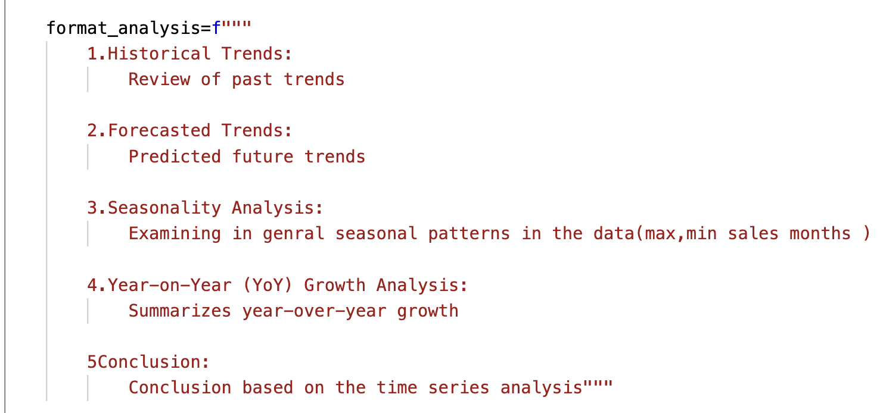

**Final Output**

